CREATE TABLE CLIENT(

CLIENT_NO VARCHAR2(6) PRIMARY KEY CHECK(CLIENT_NO LIKE 'C%'),

NAME VARCHAR2(20) NOT NULL,

CITY VARCHAR2(15),

PINCODE NUMBER(8),

STATE VARCHAR2(15),

BAL_DUE NUMBER(10,2)

);

CREATE TABLE PRODUCT(

PRODUCT_NO VARCHAR2(6) PRIMARY KEY CHECK(PRODUCT_NO LIKE 'P%'),

DESCRIPTION VARCHAR2(15) NOT NULL,

QTY_ON_HEAD NUMBER(8) NOT NULL,

SELL_PRICE NUMBER(8,2) NOT NULL CHECK(SELL_PRICE>0),

COST_PRICE NUMBER(8,2) NOT NULL CHECK(COST_PRICE>0)

);

CREATE TABLE SALESMAN(

SALESMAN_NO VARCHAR2(6) PRIMARY KEY CHECK(SALESMAN_NO LIKE 'S%'),

SALESMAN_NAME VARCHAR2(20) NOT NULL,

CITY VARCHAR2(20) NOT NULL,

PINCODE NUMBER(8) NOT NULL,

STATE VARCHAR2(20) NOT NULL,

SAL_AMT NUMBER(8,2) NOT NULL

);

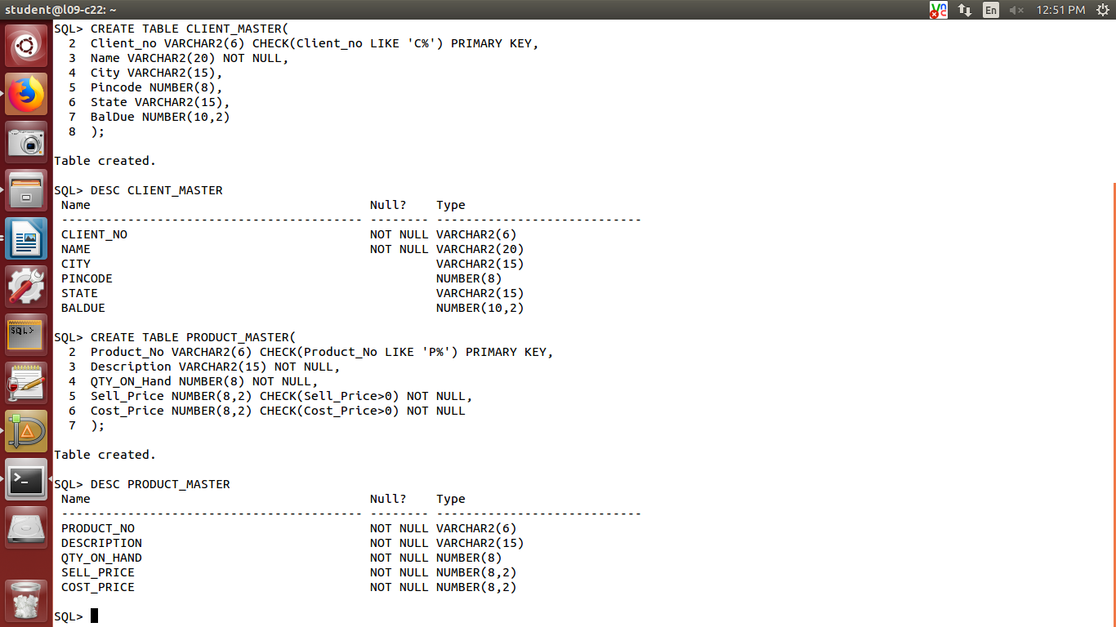

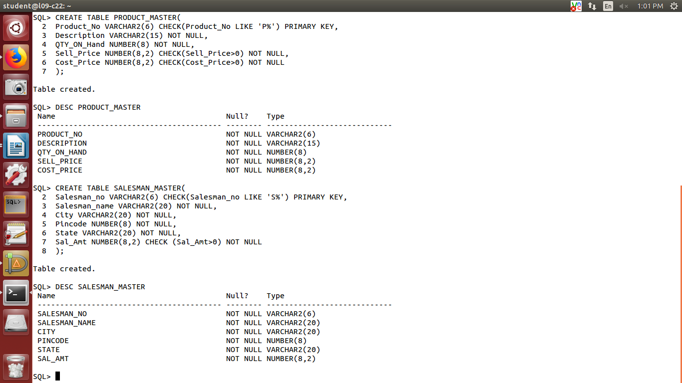

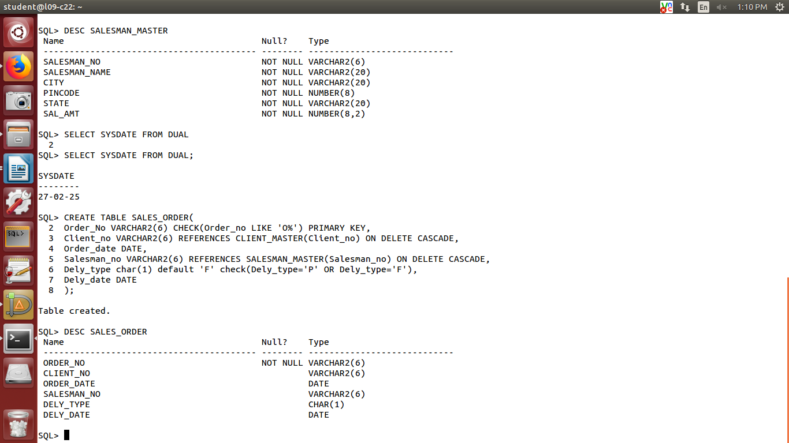

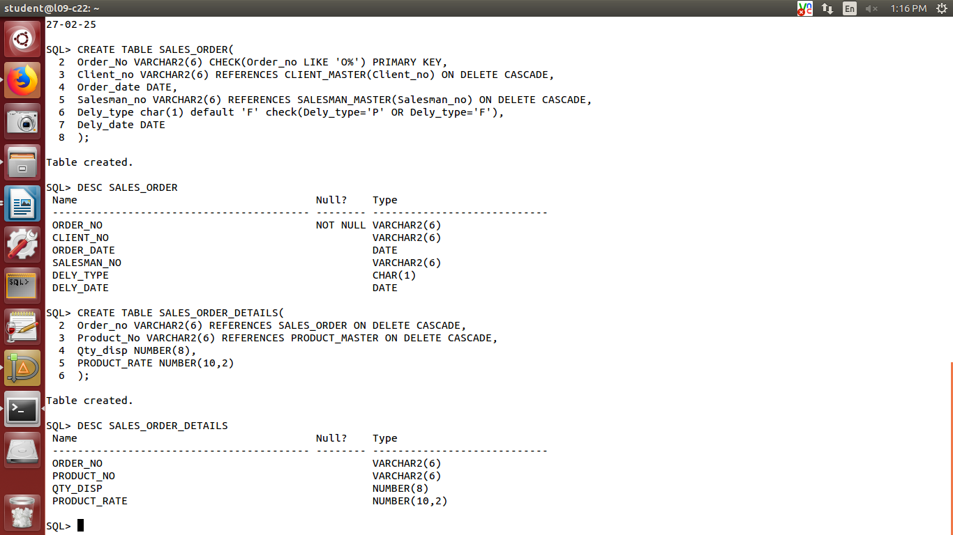

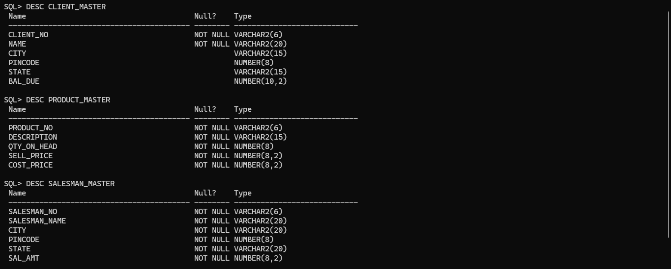

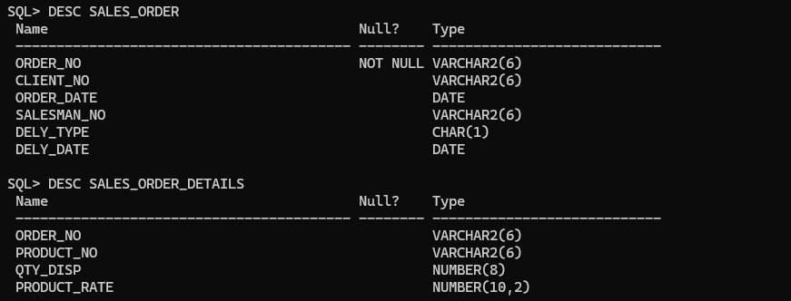

SQL> INSERT INTO CLIENT_MASTER VALUES('C00001', 'AMAN', 'KOLKATA', '700059', 'WEST BENGAL', 2000.00);

1 row created.

SQL> INSERT INTO CLIENT_MASTER VALUES('C00002', 'SHREYA', 'MUMBAI', '401105', 'MAHARASHTRA', 1000.00);

1 row created.

SQL> INSERT INTO CLIENT_MASTER VALUES('C00003', 'AKHIL', 'KOLKATA', '700062', 'WEST BENGAL', 1500.00);

1 row created.

SQL> INSERT INTO CLIENT_MASTER VALUES('C00004', 'AKANKSHA', 'DELHI', '110001', 'DELHI', 2500.00);

1 row created.

SQL> INSERT INTO CLIENT_MASTER VALUES('C00005', 'SAKSHAM', 'BENGALURU', '530068', 'KARNATAKA', 900.00);

1 row created.

SQL> COMMIT;

INSERT INTO PRODUCT_MASTER VALUES ('P001', 'Shirts', 100, 500.00, 300.00);

4 INSERT INTO PRODUCT_MASTER VALUES ('P002', 'Trousers', 150, 750.00, 500.00);

5 INSERT INTO PRODUCT_MASTER VALUES ('P003', 'Jackets', 50, 2000.00, 1500.00);

6 INSERT INTO PRODUCT_MASTER VALUES ('P004', 'Shoes', 200, 1500.00, 1200.00);

7* INSERT INTO PRODUCT_MASTER VALUES ('P005', 'Caps', 300, 300.00, 200.00);

SQL> INSERT INTO SALESMAN_MASTER VALUES ('S001', 'Rahul', 'Mumbai', 400001, 'Maharashtra', 3000);

1 row created.

SQL> INSERT INTO SALESMAN_MASTER VALUES ('S002', 'Amit', 'Delhi', 110001, 'Delhi', 3500);

1 row created.

SQL> INSERT INTO SALESMAN_MASTER VALUES ('S003', 'Sneha', 'Pune', 411001, 'Maharashtra', 4000);

1 row created.

SQL> INSERT INTO SALESMAN_MASTER VALUES ('S004', 'Ravi', 'Kolkata', 700001, 'West Bengal', 4500);

1 row created.

SQL> INSERT INTO SALESMAN_MASTER VALUES ('S005', 'Anita', 'Chennai', 600001, 'Tamil Nadu', 5000);

1 row created.

SQL> COMMIT;

SQL> INSERT INTO SALES_ORDER

2 VALUES ('O001', 'C001', TO_DATE('2025-03-01', 'YYYY-MM-DD'), 'S001', 'F', TO_DATE('2025-03-06', 'YYYY-MM-DD'));

1 row created.

SQL>

SQL> INSERT INTO SALES_ORDER

2 VALUES ('O002', 'C002', TO_DATE('2025-03-02', 'YYYY-MM-DD'), 'S002', 'P', TO_DATE('2025-03-09', 'YYYY-MM-DD'));

1 row created.

SQL>

SQL> INSERT INTO SALES_ORDER

2 VALUES ('O003', 'C003', TO_DATE('2025-02-28', 'YYYY-MM-DD'), 'S003', 'F', TO_DATE('2025-03-03', 'YYYY-MM-DD'));

1 row created.

SQL>

SQL> INSERT INTO SALES_ORDER

2 VALUES ('O004', 'C004', TO_DATE('2025-03-03', 'YYYY-MM-DD'), 'S004', 'P', TO_DATE('2025-03-07', 'YYYY-MM-DD'));

1 row created.

SQL>

SQL> INSERT INTO SALES_ORDER

2 VALUES ('O005', 'C005', TO_DATE('2025-03-05', 'YYYY-MM-DD'), 'S005', 'F', TO_DATE('2025-03-07', 'YYYY-MM-DD'));

1 row created.

SQL> COMMIT;

SQL> INSERT INTO SALES_ORDER_DETAILS VALUES ('O001', 'P001', 10, 500.00);

1 row created.

SQL> INSERT INTO SALES_ORDER_DETAILS VALUES ('O002', 'P002', 5, 750.00);

1 row created.

SQL> INSERT INTO SALES_ORDER_DETAILS VALUES ('O003', 'P003', 2, 2000.00);

1 row created.

SQL> INSERT INTO SALES_ORDER_DETAILS VALUES ('O004', 'P004', 8, 1500.00);

1 row created.

SQL> INSERT INTO SALES_ORDER_DETAILS VALUES ('O005', 'P005', 15, 300.00);

1 row created.

SQL> COMMIT;

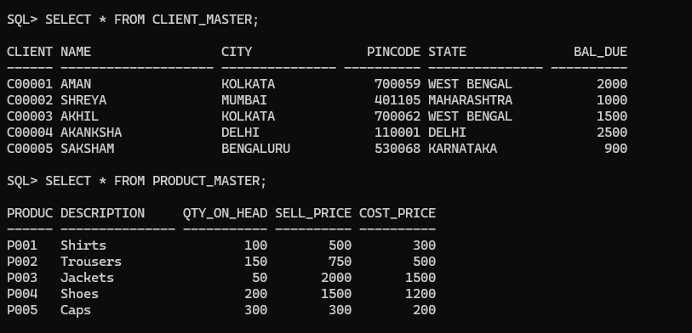

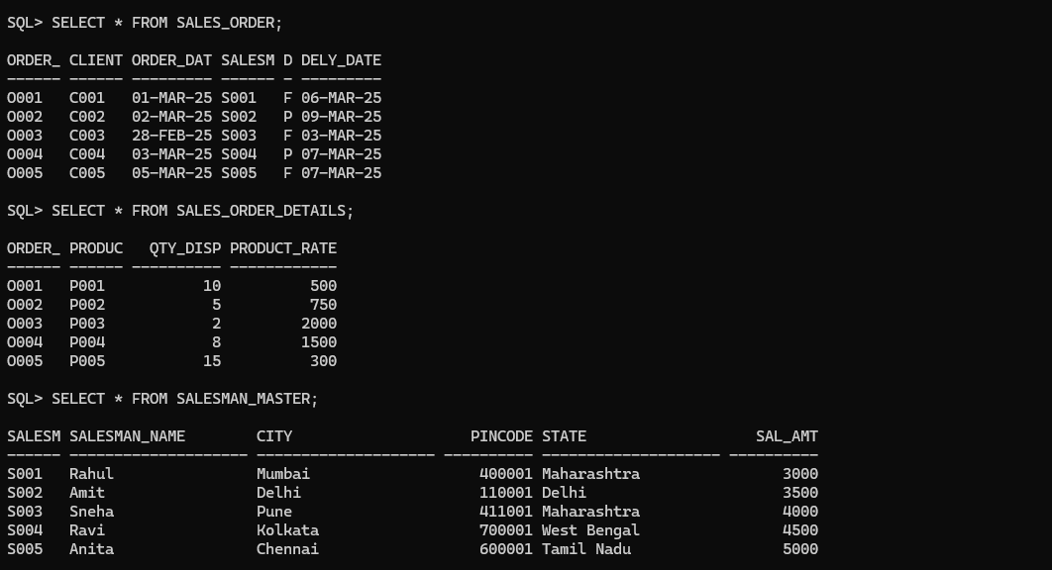

-- Find out the names of all clients

SELECT Name FROM CLIENT_MASTER;

-- Retrieve the entire contents of the Client_Master table

SELECT * FROM CLIENT_MASTER;

-- Retrieve the list of names, city, and state of all clients

SELECT Name, City, State FROM CLIENT_MASTER;

-- List the various products available from the Product_Master table

SELECT Description FROM PRODUCT_MASTER;

-- List all clients who are located in Mumbai

SELECT * FROM CLIENT_MASTER WHERE City = 'Mumbai';

-- Find the names of salesmen who have a salary equal to 3000

SELECT Salesman_name FROM SALESMAN_MASTER WHERE Sal_Amt = 3000;

-- Show the details of Product_Master according to Cost_Price in descending order

SELECT * FROM PRODUCT_MASTER ORDER BY Cost_Price DESC;

-- Show different types of salary amounts of the salesman

SELECT DISTINCT Sal_Amt FROM SALESMAN_MASTER;

-- Show only unique product details

SELECT DISTINCT * FROM PRODUCT_MASTER;

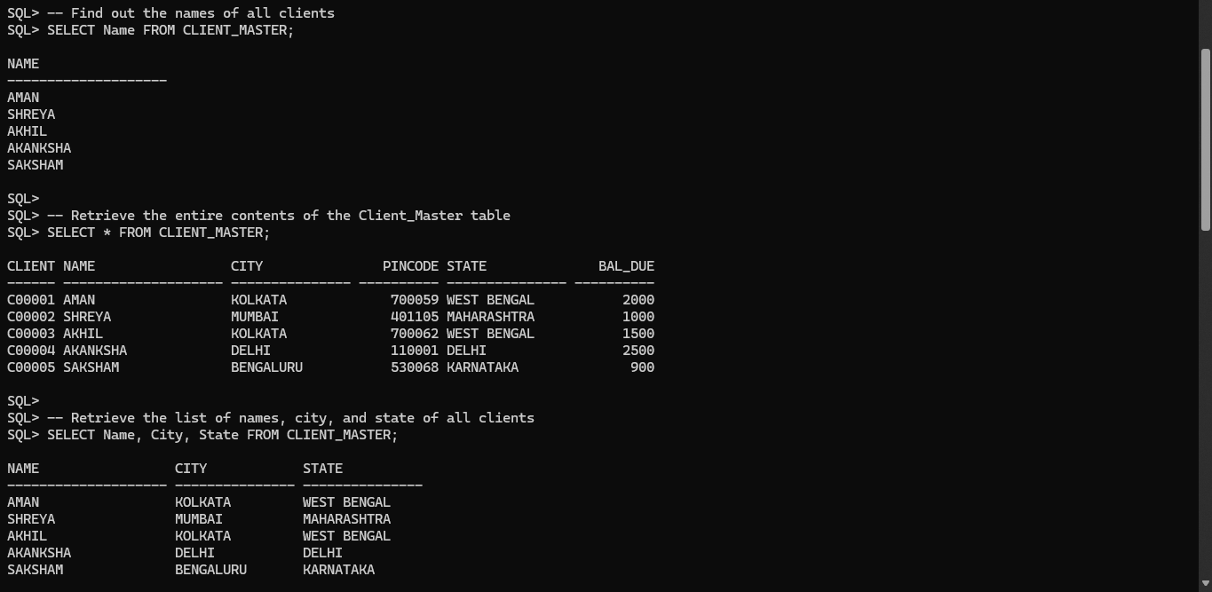

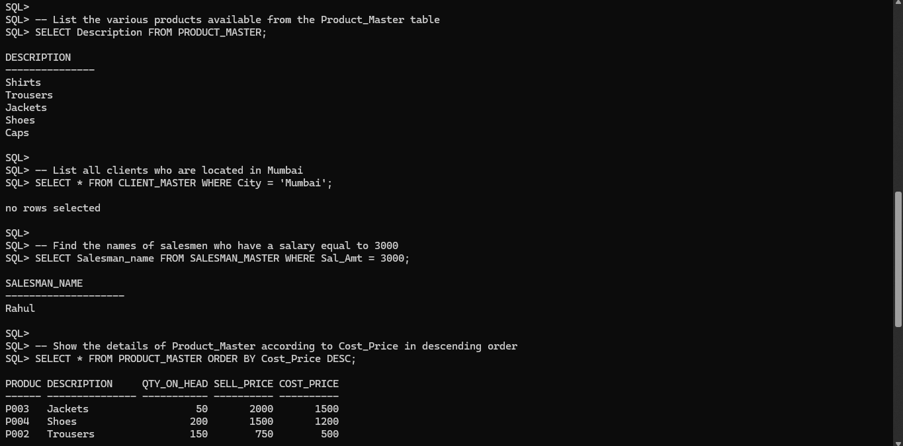

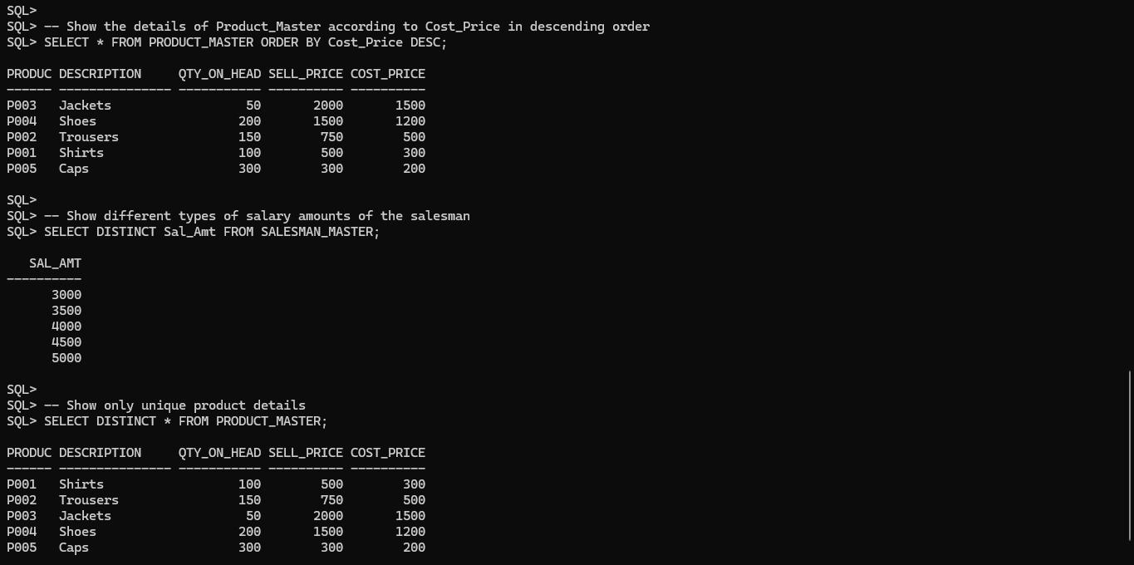

-- Change the city of client no ‘C001’ to ‘Bangalore’

UPDATE CLIENT_MASTER SET City = 'Bangalore' WHERE Client_no = 'C001';

-- Change the BalDue of client no ‘C006’ to Rs. 1000

UPDATE CLIENT_MASTER SET BalDue = 1000 WHERE Client_no = 'C006';

-- Change the cost price of ‘Trousers’ to Rs. 950.00

UPDATE PRODUCT_MASTER SET Cost_Price = 950.00 WHERE Description = 'Trousers';

-- Change the city of all salesmen to ‘Pune’

UPDATE SALESMAN_MASTER SET City = 'Pune';

-- Add a column called ‘Telephone’ of data type number and size = 10 to the Client_Master table

ALTER TABLE CLIENT_MASTER ADD Telephone NUMBER(10);

-- Change the size of Sell_Price column in Product_Master to 10, 2

ALTER TABLE PRODUCT_MASTER MODIFY Sell_Price NUMBER(10, 2);

-- Drop the column Cost_Price from Product_Master

ALTER TABLE PRODUCT_MASTER DROP COLUMN Cost_Price;

-- Delete all salesmen from the Salesman_Master whose salaries are equal to Rs. 3500

DELETE FROM SALESMAN_MASTER WHERE Sal_Amt = 3500;

-- Delete all products from Product_Master where the quantity on hand is equal to 100

DELETE FROM PRODUCT_MASTER WHERE QTY_ON_Hand = 100;

-- Delete from Client_Master where the column state holds the value ‘Tamil Nadu’

DELETE FROM CLIENT_MASTER WHERE State = 'Tamil Nadu';

-- Change the name of the Salesman_Master table to Sman_Mast

ALTER TABLE SALESMAN_MASTER RENAME TO Sman_Mast;

-- Destroy the table Client_Master along with its data

DROP TABLE CLIENT_MASTER;

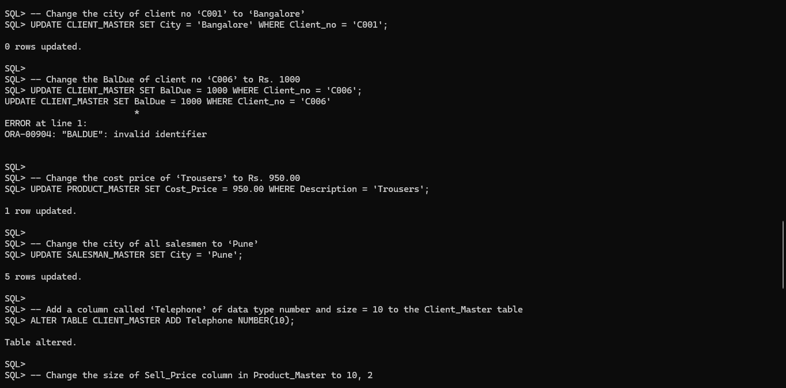

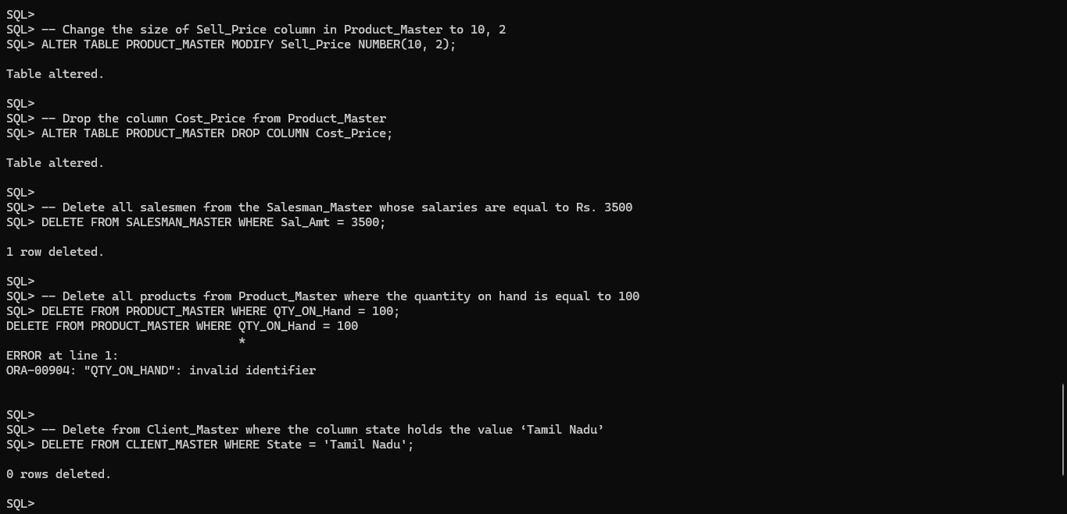

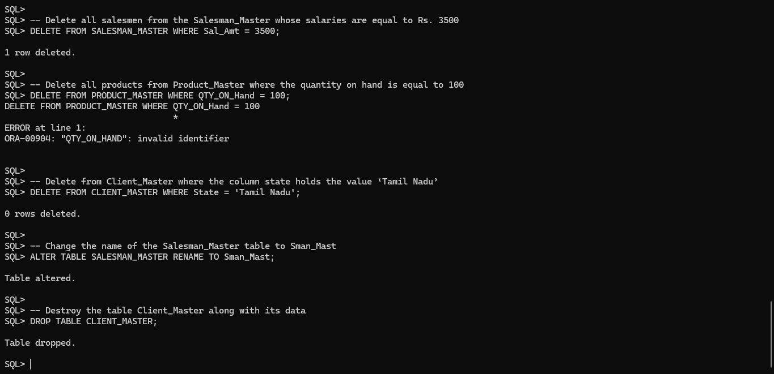

------------------------------------------------------------------------------------------------------------

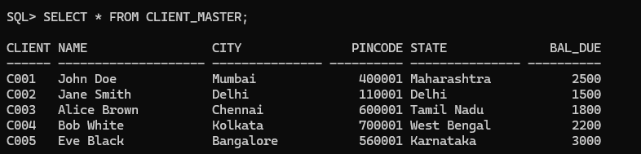

-- List the names of all clients having 'a' as the third letter in their names

SELECT Name FROM CLIENT WHERE SUBSTR(Name, 3, 1) = 'a';

-- List the clients who stay in a city whose first letter is 'K'

SELECT Name FROM CLIENT WHERE SUBSTR(City, 1, 1) = 'K';

-- List all clients who stay in 'Mumbai' or 'Kolkata'

SELECT * FROM CLIENT WHERE City IN ('Mumbai', 'Kolkata');

-- List all clients whose BalDue is greater than 1000

SELECT * FROM CLIENT WHERE BalDue > 1000;

-- List all information from SALES_ORDER table for orders placed in June

SELECT * FROM SALES_ORDER WHERE EXTRACT(MONTH FROM Order_date) = 6;

-- List order information for Client_no 'C00001' and 'C00003'

SELECT * FROM SALES_ORDER WHERE Client_no IN ('C00001', 'C00003');

-- List products whose selling price is greater than 500 and less than or equal to 750

SELECT * FROM PRODUCT WHERE Sell_Price > 500 AND Sell_Price <= 750;

-- Count the total number of orders

SELECT COUNT(*) AS Total_Orders FROM SALES_ORDER;

-- Determine maximum and minimum product prices

SELECT MAX(Sell_Price) AS Max_Price, MIN(Sell_Price) AS Min_Price FROM PRODUCT;

-- Count the number of clients who live in Kolkata

SELECT COUNT(*) AS Kolkata_Clients FROM CLIENT WHERE City = 'Kolkata';

-- Count the number of products having price less than or equal to 500

SELECT COUNT(*) AS Products_Under_500 FROM PRODUCT WHERE Sell_Price <= 500;

-- List the order number and day on which clients placed their order

SELECT Order_no, TO_CHAR(Order_date, 'Day') AS Order_Day FROM SALES_ORDER;

-- List the Order_Date in the format 'DD-Month-YY'

SELECT TO_CHAR(Order_date, 'DD-Month-YY') AS Formatted_Date FROM SALES_ORDER;

-- List the date, 20 days after today's date

SELECT SYSDATE + 20 AS Future_Date FROM DUAL;

-- List name of the client who has maximum BalDue

SELECT Name FROM CLIENT WHERE BalDue = (SELECT MAX(BalDue) FROM CLIENT);

-- Find the difference between maximum BalDue and minimum BalDue

SELECT MAX(BalDue) - MIN(BalDue) AS BalDue_Difference FROM CLIENT;

-- Add Rs.1000/- with the salary amount of every salesman

UPDATE SALESMAN SET Salary = Salary + 1000;